Physics

This article is about the field of science. For other uses, see (disambiguation)].
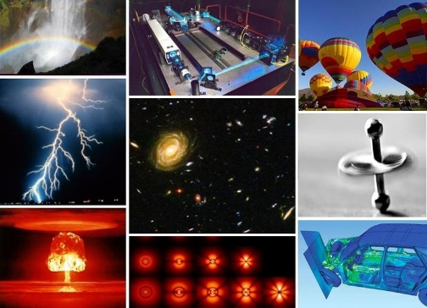
Not to be confused with Physical science.
0-1 Various examples of physical phenomena
Physics (from φυσική (ἐπιστήμη), from grc phúsis "nature") is the natural science that involves the study of matter and its motion and behavior through space and time, along with related concepts such as energy and force. One of the most fundamental scientific disciplines, the main goal of physics is to understand how the universe behaves.
Physics is one of the oldest academic disciplines, perhaps the oldest through its inclusion of astronomy. Over the last two millennia, physics was a part of natural philosophy along with chemistry, biology, and certain branches of mathematics, but during the scientific revolution in the 17th century, the natural sciences emerged as unique research programs in their own right.«/ref» Physics intersects with many interdisciplinary areas of research, such as biophysics and quantum chemistry, and the boundaries of physics are not rigidly defined. New ideas in physics often explain the fundamental mechanisms of other sciences while opening new avenues of research in areas such as mathematics and philosophy.
Physics also makes significant contributions through advances in new technologies that arise from theoretical breakthroughs. For example, advances in the understanding of electromagnetism or nuclear physics led directly to the development of new products that have dramatically transformed modern-day society, such as television, computers, domestic appliances, and nuclear weapons; advances in thermodynamics led to the development of industrialization, and advances in mechanics inspired the development of calculus.
The United Nations named 2005 the World Year of Physics.

History
Main article: History of physics

Ancient astronomy
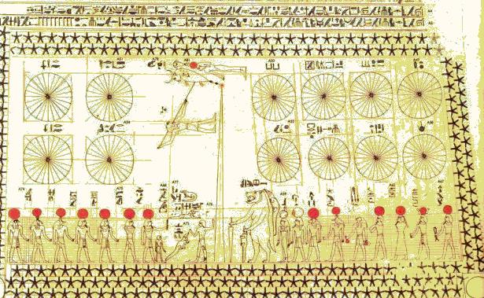
Main article: History of astronomy
0-2 Ancient [[Egyptian astronomy]] is evident in monuments like the [[Astronomical ceiling of Senemut Tomb|ceiling of Senemut's tomb]] from the [[Eighteenth Dynasty of Egypt]].
Astronomy is the oldest of the natural sciences. The earliest civilizations dating back to beyond 3000 BCE, such as the Sumerians, ancient Egyptians, and the Indus Valley Civilization, all had a predictive knowledge and a basic understanding of the motions of the Sun, Moon, and stars. The stars and planets were often a target of worship, believed to represent their gods. While the explanations for these phenomena were often unscientific and lacking in evidence, these early observations laid the foundation for later astronomy.
According to Asger Aaboe, the origins of Western astronomy can be found in Mesopotamia, and all Western efforts in the exact sciences are descended from late Babylonian astronomy. Egyptian astronomers left monuments showing knowledge of the constellations and the motions of the celestial bodies, while Greek poet Homer wrote of various celestial objects in his Iliad and Odyssey; later Greek astronomers provided names, which are still used today, for most constellations visible from the northern hemisphere.

Natural philosophy
Main article: Natural philosophy
Natural philosophy has its origins in Greece during the Archaic period, (650 BCE – 480 BCE), when pre-Socratic philosophers like Thales rejected non-naturalistic explanations for natural phenomena and proclaimed that every event had a natural cause. They proposed ideas verified by reason and observation, and many of their hypotheses proved successful in experiment; for example, atomism was found to be correct approximately 2000 years after it was first proposed by Leucippus and his pupil Democritus.

Physics in the medieval Islamic world
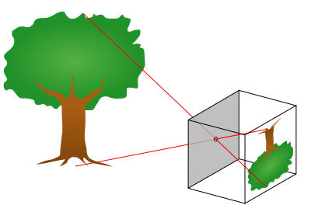
Main article: Physics in the medieval Islamic world
0-3 The basic way a pinhole camera works
Islamic scholarship had inherited Aristotelian physics from the Greeks and during the Islamic Golden Age developed it further, especially placing emphasis on observation and a priori reasoning, developing early forms of the scientific method.

The most notable innovations were in the field of optics and vision, which came from the works of many scientists like Ibn Sahl, Al-Kindi, Ibn al-Haytham, Al-Farisi and Avicenna. The most notable work was The Book of Optics (also known as Kitāb al-Manāẓir), written by Ibn Al-Haitham, in which he was not only the first to disprove the ancient Greek idea about vision, but also came up with a new theory. In the book, he was also the first to study the phenomenon of the pinhole camera and delved further into the way the eye itself works. Using dissections and the knowledge of previous scholars, he was able to begin to explain how light enters the eye, is focused, and is projected to the back of the eye: and built then the world's first camera obscura hundreds of years before the modern development of photography.
0-4 Ibn al-Haytham (c. 965 - c. 1040), the pioneer of optics
The seven-volume Book of Optics (Kitab al-Manathir) hugely influenced thinking across disciplines from the theory of visual perception to the nature of perspective in medieval art, in both the East and the West, for more than 600 years. Many later European scholars and fellow polymaths, from Robert Grosseteste and Leonardo da Vinci to René Descartes, Johannes Kepler and Isaac Newton, were in his debt. Indeed, the influence of Ibn al-Haytham's Optics ranks alongside that of Newton's work of the same title, published 700 years later.
The translation of The Book of Optics had a huge impact on Europe. From it, later European scholars were able to build the same devices as what Ibn al-Haytham did, and understand the way light works. From this, such important things as eyeglasses, magnifying glasses, telescopes, and cameras were developed.

Classical physics
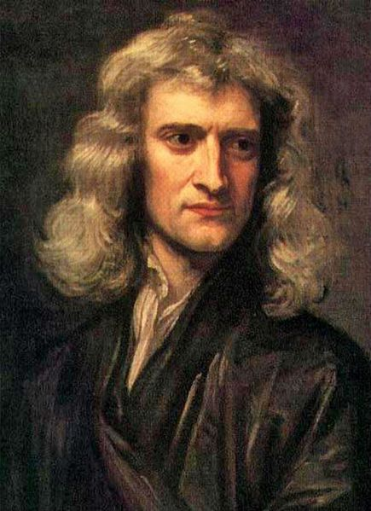
Main article: Classical physics
0-5 upright|[[Sir Isaac Newton]] (1643–1727), whose [[Newton's laws of motion|laws of motion]] and [[Newton's law of universal gravitation|universal gravitation]] were major milestones in classical physics
Physics became a separate science when early modern Europeans used experimental and quantitative methods to discover what are now considered to be the laws of physics. ^{(November 2016)">page needed]}
Major developments in this period include the replacement of the geocentric model of the solar system with the heliocentric Copernican model, the laws governing the motion of planetary bodies determined by Johannes Kepler between 1609 and 1619, pioneering work on telescopes and observational astronomy by Galileo Galilei in the 16th and 17th Centuries, and Isaac Newton's discovery and unification of the laws of motion and universal gravitation that would come to bear his name. Newton also developed calculus, the mathematical study of change, which provided new mathematical methods for solving physical problems.
The discovery of new laws in thermodynamics, chemistry, and electromagnetics resulted from greater research efforts during the Industrial Revolution as energy needs increased. The laws comprising classical physics remain very widely used for objects on everyday scales travelling at non-relativistic speeds, since they provide a very close approximation in such situations, and theories such as quantum mechanics and the theory of relativity simplify to their classical equivalents at such scales. However, inaccuracies in classical mechanics for very small objects and very high velocities led to the development of modern physics in the 20th century.

Modern physics
Main article: Modern physics
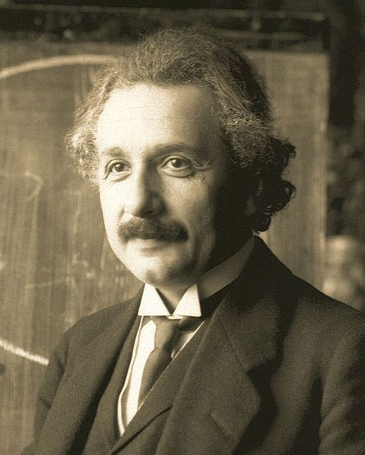
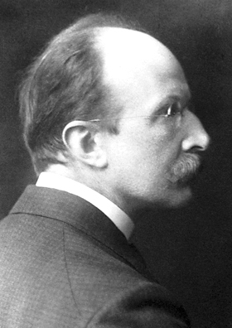
See also: History of special relativity and History of quantum mechanics
0-6 upright|[[Albert Einstein]] (1879–1955), whose work on the [[photoelectric effect]] and the [[theory of relativity]] led to a revolution in 20th century physics
0-7 upright|[[Max Planck]] (1858–1947), the originator of the theory of [[quantum mechanics]]
Modern physics began in the early 20th century with the work of Max Planck in quantum theory and Albert Einstein's theory of relativity. Both of these theories came about due to inaccuracies in classical mechanics in certain situations. Classical mechanics predicted a varying speed of light, which could not be resolved with the constant speed predicted by Maxwell's equations of electromagnetism; this discrepancy was corrected by Einstein's theory of special relativity, which replaced classical mechanics for fast-moving bodies and allowed for a constant speed of light. Black body radiation provided another problem for classical physics, which was corrected when Planck proposed that the excitation of material oscillators is possible only in discrete steps proportional to their frequency; this, along with the photoelectric effect and a complete theory predicting discrete energy levels of electron orbitals, led to the theory of quantum mechanics taking over from classical physics at very small scales.
Quantum mechanics would come to be pioneered by Werner Heisenberg, Erwin Schrödinger and Paul Dirac. From this early work, and work in related fields, the Standard Model of particle physics was derived. Following the discovery of a particle with properties consistent with the Higgs boson at CERN in 2012, all fundamental particles predicted by the standard model, and no others, appear to exist; however, physics beyond the Standard Model, with theories such as supersymmetry, is an active area of research. Areas of mathematics in general are important to this field, such as the study of probabilities and groups.

Philosophy
Main article: Philosophy of physics
In many ways, physics stems from ancient Greek philosophy. From Thales' first attempt to characterise matter, to Democritus' deduction that matter ought to reduce to an invariant state, the Ptolemaic astronomy of a crystalline firmament, and Aristotle's book Physics (an early book on physics, which attempted to analyze and define motion from a philosophical point of view), various Greek philosophers advanced their own theories of nature. Physics was known as natural philosophy until the late 18th century.Noll notes that some universities still use this title —
By the 19th century, physics was realised as a discipline distinct from philosophy and the other sciences. Physics, as with the rest of science, relies on philosophy of science and its "scientific method" to advance our knowledge of the physical world. The scientific method employs a priori reasoning as well as a posteriori reasoning and the use of Bayesian inference to measure the validity of a given theory.
The development of physics has answered many questions of early philosophers, but has also raised new questions. Study of the philosophical issues surrounding physics, the philosophy of physics, involves issues such as the nature of space and time, determinism, and metaphysical outlooks such as empiricism, naturalism and realism.
Many physicists have written about the philosophical implications of their work, for instance Laplace, who championed causal determinism, and Erwin Schrödinger, who wrote on quantum mechanics. The mathematical physicist Roger Penrose has been called a Platonist by Stephen Hawking, a view Penrose discusses in his book, The Road to Reality. Hawking refers to himself as an "unashamed reductionist" and takes issue with Penrose's views.

Core theories
Further information: Branches of physics and Outline of physics
Though physics deals with a wide variety of systems, certain theories are used by all physicists. Each of these theories were experimentally tested numerous times and found to be an adequate approximation of nature. For instance, the theory of classical mechanics accurately describes the motion of objects, provided they are much larger than atoms and moving at much less than the speed of light. These theories continue to be areas of active research today. Chaos theory, a remarkable aspect of classical mechanics was discovered in the 20th century, three centuries after the original formulation of classical mechanics by Isaac Newton (1642–1727).
These central theories are important tools for research into more specialised topics, and any physicist, regardless of their specialisation, is expected to be literate in them. These include classical mechanics, quantum mechanics, thermodynamics and statistical mechanics, electromagnetism, and special relativity.

Classical physics
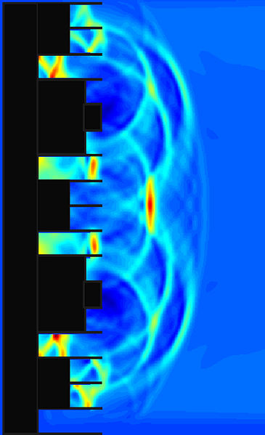
Main article: Classical physics
0-8 Classical physics implemented in an [[acoustic engineering]] model of sound reflecting from an acoustic diffuser
Classical physics includes the traditional branches and topics that were recognised and well-developed before the beginning of the 20th century—classical mechanics, acoustics, optics, thermodynamics, and electromagnetism. Classical mechanics is concerned with bodies acted on by forces and bodies in motion and may be divided into statics (study of the forces on a body or bodies not subject to an acceleration), kinematics (study of motion without regard to its causes), and dynamics (study of motion and the forces that affect it); mechanics may also be divided into solid mechanics and fluid mechanics (known together as continuum mechanics), the latter include such branches as hydrostatics, hydrodynamics, aerodynamics, and pneumatics. Acoustics is the study of how sound is produced, controlled, transmitted and received. Important modern branches of acoustics include ultrasonics, the study of sound waves of very high frequency beyond the range of human hearing; bioacoustics, the physics of animal calls and hearing, and electroacoustics, the manipulation of audible sound waves using electronics.
Optics, the study of light, is concerned not only with visible light but also with infrared and ultraviolet radiation, which exhibit all of the phenomena of visible light except visibility, e.g., reflection, refraction, interference, diffraction, dispersion, and polarization of light. Heat is a form of energy, the internal energy possessed by the particles of which a substance is composed; thermodynamics deals with the relationships between heat and other forms of energy. Electricity and magnetism have been studied as a single branch of physics since the intimate connection between them was discovered in the early 19th century; an electric current gives rise to a magnetic field, and a changing magnetic field induces an electric current. Electrostatics deals with electric charges at rest, electrodynamics with moving charges, and magnetostatics with magnetic poles at rest.

Modern physics
Main article: Modern physics
Modern physics
hat{H} | psi_n(t) rangle = i hbar frac{partial}{partial t} | psi_n(t) rangle
frac { 1 }{ { c }^{ 2 } } frac { { partial }^{ 2 }{ phi }_{n} }{ { partial t }^{ 2 } } -{ { abla }^{ 2 }{ phi }_{n} }+{ left( frac { mc }{ hbar } right) }^{ 2 }{ phi }_{n}=0
Manifold dynamics: Schrödinger and Klein–Gordon equations
Founders
Max Planck · Albert Einstein · Niels Bohr · Max Born · Werner Heisenberg · Erwin Schrödinger · Pascual Jordan · Wolfgang Pauli · Paul Dirac · Ernest Rutherford · Louis de Broglie · Satyendra Nath Bose
Concepts
Topology · space · time · energy · matter · work
randomness · information · entropy · mind
light · particle · wave
Branches
Applied · Experimental · Theoretical
Philosophy of Science · Philosophy of physics
Mathematical logic · Mathematical physics
Supersymmetry · String theory · M-theory
Grand Unified Theory · Standard model
Quantum mechanics · Quantum field theory
Antiparticle · Antimatter
Electromagnetism · Quantum electrodynamics
Weak interaction · Electroweak interaction
Strong interaction · Quantum chromodynamics
Atomic physics · Particle physics · Nuclear physics
Exotic matter · Higgs boson
Atomic, molecular, and optical physics
Condensed matter physics
Quantum statistical mechanics
Quantum information · Quantum computation
Spintronics · Superconductivity
Non-linear dynamics · Photonics · Biophysics
Neurophysics · Quantum mind
Plasma physics · Neutrino astronomy
Special relativity · General relativity
Scale relativity · Spacetime symmetries
Dark matter · Dark energy
Fractal analysis · Quantum chaos
Emergence · Complex systems
Black Holes · Holographic principle
Astrophysics · Observable universe
Big Bang · Cosmology
Theories of gravitation · Loop quantum gravity
Quantum gravity · Theory of Everything
Mathematical universe hypothesis · Multiverse · Weak Gravity Conjecture
Scientists
Röntgen · Becquerel · Lorentz · Planck · Curie · Wien · Sklodowska-Curie · Sommerfeld · Rutherford · Soddy · Onnes · Einstein · Wilczek · Born · Weyl · Bohr · Schrödinger · de Broglie · Laue · Bose · Compton · Pauli · Walton · Fermi · van der Waals · Heisenberg · Dyson · Zeeman · Moseley · Hilbert · Gödel · Jordan · Dirac · Wigner · Hawking · P.W Anderson · Lemaître · Thomson · Poincaré · Wheeler · Penrose · Millikan · Nambu · von Neumann · Higgs · Hahn · Feynman · Lee · Lenard · Salam · 't Hooft · Bell · Gell-Mann · J. J. Thomson · Raman · Bragg · Bardeen · Shockley · Chadwick · Lawrence · Zeilinger
- v
- t
- e
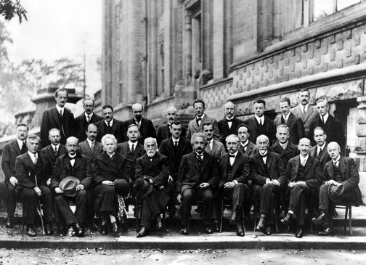
0-9 [[Solvay Conference]] of 1927, with prominent physicists such as [[Albert Einstein]], [[Werner Heisenberg]], [[Max Planck]], [[Hendrik Lorentz]], [[Niels Bohr]], [[Marie Curie]], [[Erwin Schrödinger]] and [[Paul Dirac]]
Classical physics is generally concerned with matter and energy on the normal scale of observation, while much of modern physics is concerned with the behavior of matter and energy under extreme conditions or on a very large or very small scale. For example, atomic and nuclear physics studies matter on the smallest scale at which chemical elements can be identified. The physics of elementary particles is on an even smaller scale since it is concerned with the most basic units of matter; this branch of physics is also known as high-energy physics because of the extremely high energies necessary to produce many types of particles in particle accelerators. On this scale, ordinary, commonsense notions of space, time, matter, and energy are no longer valid.
The two chief theories of modern physics present a different picture of the concepts of space, time, and matter from that presented by classical physics. Classical mechanics approximates nature as continuous, while quantum theory is concerned with the discrete nature of many phenomena at the atomic and subatomic level and with the complementary aspects of particles and waves in the description of such phenomena. The theory of relativity is concerned with the description of phenomena that take place in a frame of reference that is in motion with respect to an observer; the special theory of relativity is concerned with relative uniform motion in a straight line and the general theory of relativity with accelerated motion and its connection with gravitation. Both quantum theory and the theory of relativity find applications in all areas of modern physics.

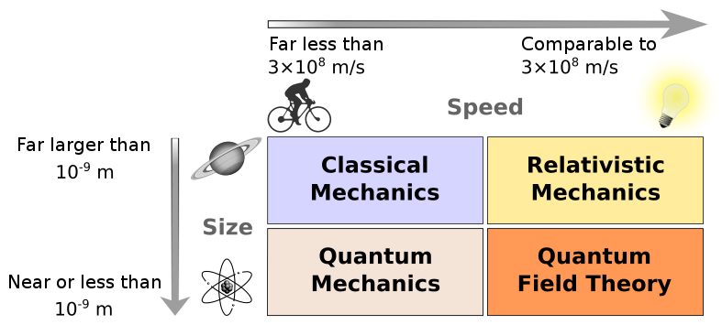
Difference between classical and modern physics
0-10 The basic domains of physics
While physics aims to discover universal laws, its theories lie in explicit domains of applicability. Loosely speaking, the laws of classical physics accurately describe systems whose important length scales are greater than the atomic scale and whose motions are much slower than the speed of light. Outside of this domain, observations do not match predictions provided by classical mechanics. Albert Einstein contributed the framework of special relativity, which replaced notions of absolute time and space with spacetime and allowed an accurate description of systems whose components have speeds approaching the speed of light. Max Planck, Erwin Schrödinger, and others introduced quantum mechanics, a probabilistic notion of particles and interactions that allowed an accurate description of atomic and subatomic scales. Later, quantum field theory unified quantum mechanics and special relativity. General relativity allowed for a dynamical, curved spacetime, with which highly massive systems and the large-scale structure of the universe can be well-described. General relativity has not yet been unified with the other fundamental descriptions; several candidate theories of quantum gravity are being developed.


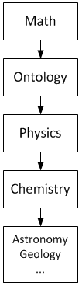
Relation to other fields
0-11 This [[parabola]]-shaped [[lava flow]] illustrates the application of mathematics in physics—in this case, [[Galileo]]'s [[law of falling bodies]].
0-12 Mathematics and ontology are used in physics. Physics is used in chemistry and cosmology.

Prerequisites
Mathematics provides a compact and exact language used to describe of the order in nature. This was noted and advocated by Pythagoras, Plato, Galileo, and Newton.
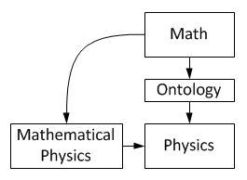
Physics uses mathematics to organise and formulate experimental results. From those results, precise or estimated solutions, quantitative results from which new predictions can be made and experimentally confirmed or negated. The results from physics experiments are numerical measurements. Technologies based on mathematics, like computation have made computational physics an active area of research.
0-13 The distinction between mathematics and physics is clear-cut, but not always obvious, especially in mathematical physics.
Ontology is a prerequisite for physics, but not for mathematics. It means physics is ultimately concerned with descriptions of the real world, while mathematics is concerned with abstract patterns, even beyond the real world. Thus physics statements are synthetic, while mathematical statements are analytic. Mathematics contains hypotheses, while physics contains theories. Mathematics statements have to be only logically true, while predictions of physics statements must match observed and experimental data.
The distinction is clear-cut, but not always obvious. For example, mathematical physics is the application of mathematics in physics. Its methods are mathematical, but its subject is physical. The problems in this field start with a "mathematical model of a physical situation" (system) and a "mathematical description of a physical law" that will be applied to that system. Every mathematical statement used for solving has a hard-to-find physical meaning. The final mathematical solution has an easier-to-find meaning, because it is what the solver is looking for. (August 2015)">clarification needed]
Physics is a branch of fundamental science, not practical science. Physics is also called "the fundamental science" because the subject of study of all branches of natural science like chemistry, astronomy, geology, and biology are constrained by laws of physics, similar to how chemistry is often called the central science because of its role in linking the physical sciences. For example, chemistry studies properties, structures, and reactions of matter (chemistry's focus on the atomic scale distinguishes it from physics). Structures are formed because particles exert electrical forces on each other, properties include physical characteristics of given substances, and reactions are bound by laws of physics, like conservation of energy, mass, and charge.
Physics is applied in industries like engineering and medicine.

Application and influence
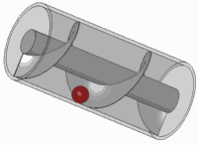
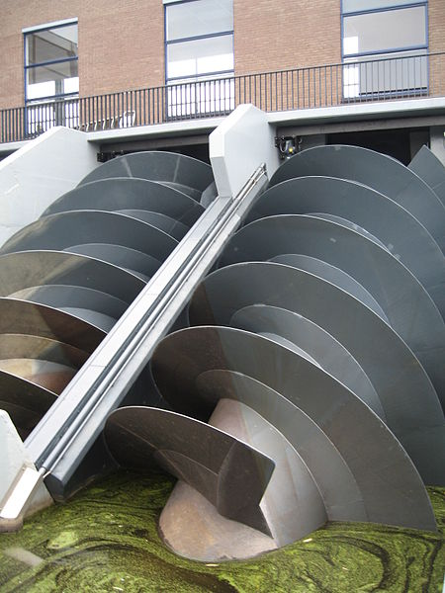
Main article: Applied physics
0-14 [[Archimedes' screw]], a [[simple machine]] for lifting
0-15 The application of physical laws in lifting liquids
Applied physics is a general term for physics research which is intended for a particular use. An applied physics curriculum usually contains a few classes in an applied discipline, like geology or electrical engineering. It usually differs from engineering in that an applied physicist may not be designing something in particular, but rather is using physics or conducting physics research with the aim of developing new technologies or solving a problem.
The approach is similar to that of applied mathematics. Applied physicists use physics in scientific research. For instance, people working on accelerator physics might seek to build better particle detectors for research in theoretical physics.
Physics is used heavily in engineering. For example, statics, a subfield of mechanics, is used in the building of bridges and other static structures. The understanding and use of acoustics results in sound control and better concert halls; similarly, the use of optics creates better optical devices. An understanding of physics makes for more realistic flight simulators, video games, and movies, and is often critical in forensic investigations.
With the standard consensus that the laws of physics are universal and do not change with time, physics can be used to study things that would ordinarily be mired in uncertainty. For example, in the study of the origin of the earth, one can reasonably model earth's mass, temperature, and rate of rotation, as a function of time allowing one to extrapolate forward or backward in time and so predict future or prior events. It also allows for simulations in engineering which drastically speed up the development of a new technology.
But there is also considerable interdisciplinarity in the physicist's methods, so many other important fields are influenced by physics (e.g., the fields of econophysics and sociophysics).

Research

Scientific method
Physicists use the scientific method to test the validity of a physical theory. By using a methodical approach to compare the implications of a theory with the conclusions drawn from its related experiments and observations, physicists are better able to test the validity of a theory in a logical, unbiased, and repeatable way. To that end, experiments are performed and observations are made in order to determine the validity or invalidity of the theory.
A scientific law is a concise verbal or mathematical statement of a relation which expresses a fundamental principle of some theory, such as Newton's law of universal gravitation.

Theory and experiment


Main articles: Theoretical physics and Experimental physics
0-16 The [[astronaut]] and [[Earth]] are both in [[free-fall]]
0-17 [[Lightning]] is an [[electric current]]
Theorists seek to develop mathematical models that both agree with existing experiments and successfully predict future experimental results, while experimentalists devise and perform experiments to test theoretical predictions and explore new phenomena. Although theory and experiment are developed separately, they are strongly dependent upon each other. Progress in physics frequently comes about when experimentalists make a discovery that existing theories cannot explain, or when new theories generate experimentally testable predictions, which inspire new experiments.
Physicists who work at the interplay of theory and experiment are called phenomenologists, who study complex phenomena observed in experiment and work to relate them to a fundamental theory.
Theoretical physics has historically taken inspiration from philosophy; electromagnetism was unified this way. Beyond the known universe, the field of theoretical physics also deals with hypothetical issues, such as parallel universes, a multiverse, and higher dimensions. Theorists invoke these ideas in hopes of solving particular problems with existing theories. They then explore the consequences of these ideas and work toward making testable predictions.
Experimental physics expands, and is expanded by, engineering and technology. Experimental physicists involved in basic research design and perform experiments with equipment such as particle accelerators and lasers, whereas those involved in applied research often work in industry developing technologies such as magnetic resonance imaging (MRI) and transistors. Feynman has noted that experimentalists may seek areas which are not well-explored by theorists.

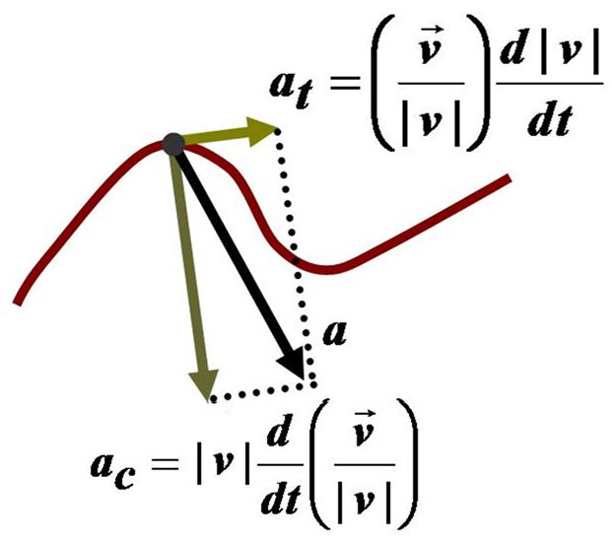
Scope and aims
0-18 Physics involves modeling the natural world with theory, usually quantitative. Here, the path of a particle is modeled with the mathematics of [[calculus]] to explain its behavior: the purview of the branch of physics known as [[mechanics]].
Physics covers a wide range of phenomena, from elementary particles (such as quarks, neutrinos, and electrons) to the largest superclusters of galaxies. Included in these phenomena are the most basic objects composing all other things. Therefore, physics is sometimes called the "fundamental science". Physics aims to describe the various phenomena that occur in nature in terms of simpler phenomena. Thus, physics aims to both connect the things observable to humans to root causes, and then connect these causes together.
For example, the ancient Chinese observed that certain rocks (lodestone and magnetite) were attracted to one another by an invisible force. This effect was later called magnetism, which was first rigorously studied in the 17th century. But even before the Chinese discovered magnetism, the ancient Greeks knew of other objects such as amber, that when rubbed with fur would cause a similar invisible attraction between the two. This was also first studied rigorously in the 17th century and came to be called electricity. Thus, physics had come to understand two observations of nature in terms of some root cause (electricity and magnetism). However, further work in the 19th century revealed that these two forces were just two different aspects of one force—electromagnetism. This process of "unifying" forces continues today, and electromagnetism and the weak nuclear force are now considered to be two aspects of the electroweak interaction. Physics hopes to find an ultimate reason (Theory of Everything) for why nature is as it is (see section Current research below for more information).

Research fields
Contemporary research in physics can be broadly divided into nuclear and particle physics; condensed matter physics; atomic, molecular, and optical physics; astrophysics; and applied physics. Some physics departments also support physics education research and physics outreach.
Since the 20th century, the individual fields of physics have become increasingly specialised, and today most physicists work in a single field for their entire careers. "Universalists" such as Albert Einstein (1879–1955) and Lev Landau (1908–1968), who worked in multiple fields of physics, are now very rare.
The major fields of physics, along with their subfields and the theories and concepts they employ, are shown in the following table.
| Subfields || Major theories || Concepts
Nuclear and particle physics | Nuclear physics, Nuclear astrophysics, Particle physics, Particle astrophysics, Particle physics phenomenology | Standard Model, Quantum field theory, Quantum electrodynamics, Quantum chromodynamics, Electroweak theory, Effective field theory, Lattice field theory, Lattice gauge theory, Gauge theory, Supersymmetry, Grand unification theory, Superstring theory, M-theory | Fundamental force (gravitational, electromagnetic, weak, strong), Elementary particle, Spin, Antimatter, Spontaneous symmetry breaking, Neutrino oscillation, Seesaw mechanism, Brane, String, Quantum gravity, Theory of everything, Vacuum energy
Atomic, molecular, and optical physics | Atomic physics, Molecular physics, Atomic and Molecular astrophysics, Chemical physics, Optics, Photonics | Quantum optics, Quantum chemistry, Quantum information science | Photon, Atom, Molecule, Diffraction, Electromagnetic radiation, Laser, Polarization (waves), Spectral line, Casimir effect
Condensed matter physics | Solid state physics, High pressure physics, Low-temperature physics, Surface Physics, Nanoscale and Mesoscopic physics, Polymer physics | BCS theory, Bloch wave, Density functional theory, Fermi gas, Fermi liquid, Many-body theory, Statistical Mechanics | Phases (gas, liquid, solid), Bose-Einstein condensate, Electrical conduction, Phonon, Magnetism, Self-organization, Semiconductor, superconductor, superfluid, Spin,
Astrophysics | Astronomy, Astrometry, Cosmology, Gravitation physics, High-energy astrophysics, Planetary astrophysics, Plasma physics, Solar physics, Space physics, Stellar astrophysics | Big Bang, Cosmic inflation, General relativity, Newton's law of universal gravitation, Lambda-CDM model, Magnetohydrodynamics | Black hole, Cosmic background radiation, Cosmic string, Cosmos, Dark energy, Dark matter, Galaxy, Gravity, Gravitational radiation, Gravitational singularity, Planet, Solar System, Star, Supernova, Universe
Applied Physics | Accelerator physics, Acoustics, Agrophysics, Biophysics, Chemical Physics, Communication Physics, Econophysics, Engineering physics, Fluid dynamics, Geophysics, Laser Physics, Materials physics, Medical physics, Nanotechnology, Optics, Optoelectronics, Photonics, Photovoltaics, Physical chemistry, Physics of computation, Plasma physics, Solid-state devices, Quantum chemistry, Quantum electronics, Quantum information science, Vehicle dynamics

Nuclear and particle physics
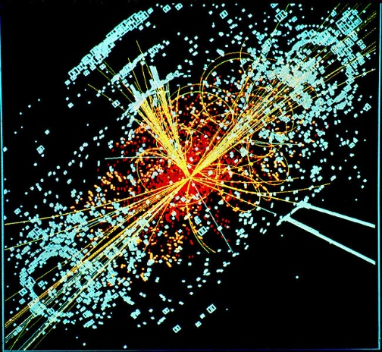
Main articles: Particle physics and Nuclear physics
0-19 A simulated event in the CMS detector of the [[Large Hadron Collider]], featuring a possible appearance of the [[Higgs boson]].
Particle physics is the study of the elementary constituents of matter and energy and the interactions between them. In addition, particle physicists design and develop the high energy accelerators, detectors, and computer programs necessary for this research. The field is also called "high-energy physics" because many elementary particles do not occur naturally but are created only during high-energy collisions of other particles.
Currently, the interactions of elementary particles and fields are described by the Standard Model. The model accounts for the 12 known particles of matter (quarks and leptons) that interact via the strong, weak, and electromagnetic fundamental forces. Dynamics are described in terms of matter particles exchanging gauge bosons (gluons, W and Z bosons, and photons, respectively). The Standard Model also predicts a particle known as the Higgs boson. In July 2012 CERN, the European laboratory for particle physics, announced the detection of a particle consistent with the Higgs boson, an integral part of a Higgs mechanism.
Nuclear physics is the field of physics that studies the constituents and interactions of atomic nuclei. The most commonly known applications of nuclear physics are nuclear power generation and nuclear weapons technology, but the research has provided application in many fields, including those in nuclear medicine and magnetic resonance imaging, ion implantation in materials engineering, and radiocarbon dating in geology and archaeology.

Atomic, molecular, and optical physics
Main article: Atomic, molecular, and optical physics
Atomic, molecular, and optical physics (AMO) is the study of matter–matter and light–matter interactions on the scale of single atoms and molecules. The three areas are grouped together because of their interrelationships, the similarity of methods used, and the commonality of their relevant energy scales. All three areas include both classical, semi-classical and quantum treatments; they can treat their subject from a microscopic view (in contrast to a macroscopic view).
Atomic physics studies the electron shells of atoms. Current research focuses on activities in quantum control, cooling and trapping of atoms and ions,For example, AMO research groups at low-temperature collision dynamics and the effects of electron correlation on structure and dynamics. Atomic physics is influenced by the nucleus (see, e.g., hyperfine splitting), but intra-nuclear phenomena such as fission and fusion are considered part of nuclear physics.
Molecular physics focuses on multi-atomic structures and their internal and external interactions with matter and light. Optical physics is distinct from optics in that it tends to focus not on the control of classical light fields by macroscopic objects but on the fundamental properties of optical fields and their interactions with matter in the microscopic realm.

Condensed matter physics
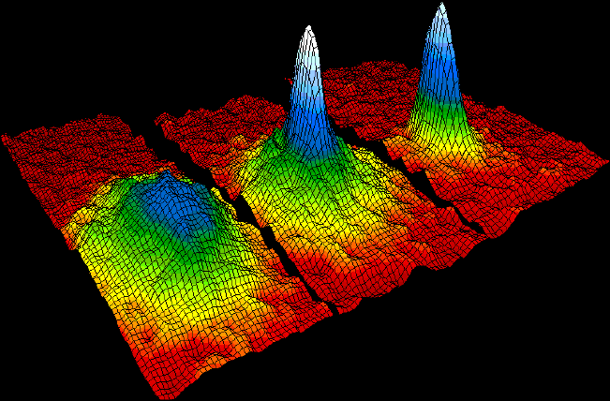
Main article: Condensed matter physics
0-20 Velocity-distribution data of a gas of [[rubidium]] atoms, confirming the discovery of a new phase of matter, the [[Bose–Einstein condensate]]
Condensed matter physics is the field of physics that deals with the macroscopic physical properties of matter. In particular, it is concerned with the "condensed" phases that appear whenever the number of particles in a system is extremely large and the interactions between them are strong.
The most familiar examples of condensed phases are solids and liquids, which arise from the bonding by way of the electromagnetic force between atoms. More exotic condensed phases include the superfluid and the Bose–Einstein condensate found in certain atomic systems at very low temperature, the superconducting phase exhibited by conduction electrons in certain materials, and the ferromagnetic and antiferromagnetic phases of spins on atomic lattices.
Condensed matter physics is the largest field of contemporary physics. Historically, condensed matter physics grew out of solid-state physics, which is now considered one of its main subfields. The term condensed matter physics was apparently coined by Philip Anderson when he renamed his research group—previously solid-state theory—in 1967. In 1978, the Division of Solid State Physics of the American Physical Society was renamed as the Division of Condensed Matter Physics. Condensed matter physics has a large overlap with chemistry, materials science, nanotechnology and engineering.

Astrophysics
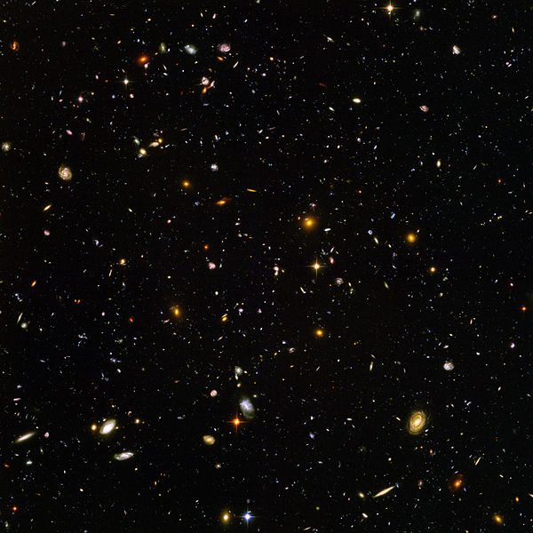
Main articles: Astrophysics and Physical cosmology
0-21 The deepest visible-light image of the [[universe]], the [[Hubble Ultra Deep Field]]
Astrophysics and astronomy are the application of the theories and methods of physics to the study of stellar structure, stellar evolution, the origin of the Solar System, and related problems of cosmology. Because astrophysics is a broad subject, astrophysicists typically apply many disciplines of physics, including mechanics, electromagnetism, statistical mechanics, thermodynamics, quantum mechanics, relativity, nuclear and particle physics, and atomic and molecular physics.
The discovery by Karl Jansky in 1931 that radio signals were emitted by celestial bodies initiated the science of radio astronomy. Most recently, the frontiers of astronomy have been expanded by space exploration. Perturbations and interference from the earth's atmosphere make space-based observations necessary for infrared, ultraviolet, gamma-ray, and X-ray astronomy.
Physical cosmology is the study of the formation and evolution of the universe on its largest scales. Albert Einstein's theory of relativity plays a central role in all modern cosmological theories. In the early 20th century, Hubble's discovery that the universe is expanding, as shown by the Hubble diagram, prompted rival explanations known as the steady state universe and the Big Bang.
The Big Bang was confirmed by the success of Big Bang nucleosynthesis and the discovery of the cosmic microwave background in 1964. The Big Bang model rests on two theoretical pillars: Albert Einstein's general relativity and the cosmological principle. Cosmologists have recently established the ΛCDM model of the evolution of the universe, which includes cosmic inflation, dark energy, and dark matter.
Numerous possibilities and discoveries are anticipated to emerge from new data from the Fermi Gamma-ray Space Telescope over the upcoming decade and vastly revise or clarify existing models of the universe. In particular, the potential for a tremendous discovery surrounding dark matter is possible over the next several years. Fermi will search for evidence that dark matter is composed of weakly interacting massive particles, complementing similar experiments with the Large Hadron Collider and other underground detectors.
IBEX is already yielding new astrophysical discoveries: "No one knows what is creating the ENA (energetic neutral atoms) ribbon" along the termination shock of the solar wind, "but everyone agrees that it means the textbook picture of the heliosphere—in which the Solar System's enveloping pocket filled with the solar wind's charged particles is plowing through the onrushing 'galactic wind' of the interstellar medium in the shape of a comet—is wrong."

Current research
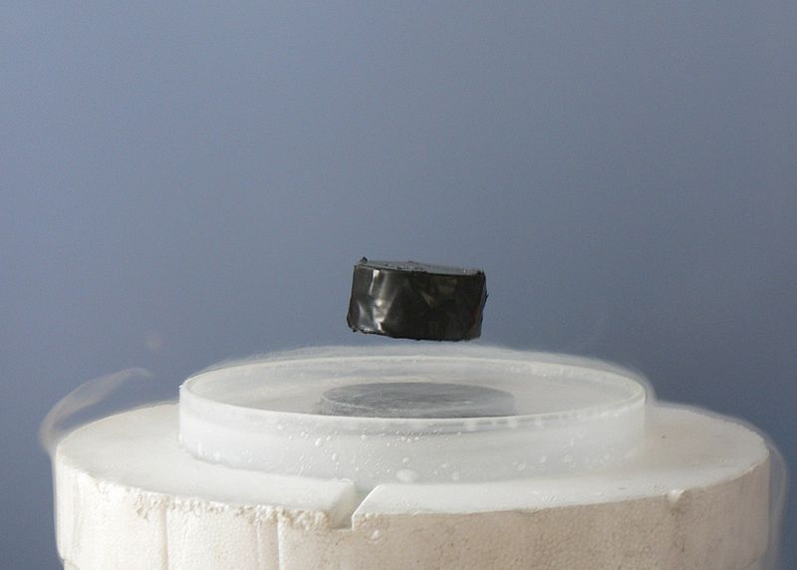
Further information: List of unsolved problems in physics
0-22 A typical event described by physics: a [[magnet]] levitating above a [[superconductor]] demonstrates the [[Meissner effect]].
Research in physics is continually progressing on a large number of fronts.
In condensed matter physics, an important unsolved theoretical problem is that of high-temperature superconductivity. Many condensed matter experiments are aiming to fabricate workable spintronics and quantum computers.
In particle physics, the first pieces of experimental evidence for physics beyond the Standard Model have begun to appear. Foremost among these are indications that neutrinos have non-zero mass. These experimental results appear to have solved the long-standing solar neutrino problem, and the physics of massive neutrinos remains an area of active theoretical and experimental research. The Large Hadron Collider has already found the Higgs Boson, but future research aims to prove or disprove the supersymmetry, which extends the Standard Model of particle physics. Research on the nature of the major mysteries of dark matter and dark energy is also currently ongoing.
Theoretical attempts to unify quantum mechanics and general relativity into a single theory of quantum gravity, a program ongoing for over half a century, have not yet been decisively resolved. The current leading candidates are M-theory, superstring theory and loop quantum gravity.
Many astronomical and cosmological phenomena have yet to be satisfactorily explained, including the origin of ultra-high energy cosmic rays, the baryon asymmetry, the acceleration of the universe and the anomalous rotation rates of galaxies.
Although much progress has been made in high-energy, quantum, and astronomical physics, many everyday phenomena involving complexity, chaos, or turbulence are still poorly understood. Complex problems that seem like they could be solved by a clever application of dynamics and mechanics remain unsolved; examples include the formation of sandpiles, nodes in trickling water, the shape of water droplets, mechanisms of surface tension catastrophes, and self-sorting in shaken heterogeneous collections.See the work of Ilya Prigogine, on 'systems far from equilibrium', and others, e.g.,
These complex phenomena have received growing attention since the 1970s for several reasons, including the availability of modern mathematical methods and computers, which enabled complex systems to be modeled in new ways. Complex physics has become part of increasingly interdisciplinary research, as exemplified by the study of turbulence in aerodynamics and the observation of pattern formation in biological systems. In the 1932 Annual Review of Fluid Mechanics, Horace Lamb said:
I am an old man now, and when I die and go to heaven there are two matters on which I hope for enlightenment. One is quantum electrodynamics, and the other is the turbulent motion of fluids. And about the former I am rather optimistic.

See also

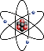
- portal]
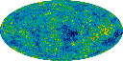
- portal]

 | - Book: Physics

General  Glossary of classical physics  Glossary of physics  Index of physics articles  List of elementary physics formulae, Elementary physics formulae  List of important publications in physics  List of physicists  List of physics concepts in primary and secondary education curricula  Outline of physics  Physics outreach  Perfection in physics and chemistry  Relationship between mathematics and physics  Timeline of developments in theoretical physics  Timeline of fundamental physics discoveries  Main branches  Classical mechanics  Electromagnetism  Modern physics  Optics  Thermodynamics | Related fields  Astronomy  Chemistry  Engineering  Mathematics  Cosmology  Interdisciplinary fields incorporating physics  Acoustics  Biophysics  Econophysics  Geophysics  Nanotechnology  Neurophysics  Psychophysics

Notes

References

Sources

Further reading
- Peter Woit (January 2017). Fake Physics,

External links
 | This article's use of external links may not follow Wikipedia's policies or guidelines. Please improve this article by removing excessive or inappropriate external links, and converting useful links where appropriate into footnote references. (July 2015) (Learn how and when to remove this template message)

 | Look up physics in Wiktionary, the free dictionary.

 | Wikibooks has a book on the topic of: Physics

Wikibooks has a book on the topic of: Physics Study Guide

Wikibooks has a book on the topic of: FHSST Physics

 | Wikisource has original works on the topic: Physics

 | Wikiversity has learning resources about Category:Physics

General
- Encyclopedia of Physics at Scholarpedia
- de Haas, Paul, Historic Papers in Physics (20th Century) at the Wayback Machine(archived 26 August 2009)
- PhysicsCentral – Web portal run by the American Physical Society
- Physics.org – Web portal run by the Institute of Physics
- The Skeptic's Guide to Physics
- Usenet Physics FAQ – A FAQ compiled by sci.physics and other physics newsgroups
- Website of the Nobel Prize in physics
- World of Physics An online encyclopedic dictionary of physics
- Nature: Physics
- Physics announced 17 July 2008 by the American Physical Society
- Physics/Publications at DMOZ
- Physicsworld.com – News website from Institute of Physics Publishing
- Physics Central – includes articles on astronomy, particle physics, and mathematics.
- The Vega Science Trust – science videos, including physics
- Video: Physics "Lightning" Tour with Justin Morgan
- 52-part video course: The Mechanical Universe...and Beyond Note: also available at 01 – Introduction at Google Videos
- HyperPhysics website – HyperPhysics, a physics and astronomy mind-map from Georgia State University
Organizations
- AIP.org – Website of the American Institute of Physics
- APS.org – Website of the American Physical Society
- IOP.org – Website of the Institute of Physics
- PlanetPhysics.org
- Royal Society – Although not exclusively a physics institution, it has a strong history of physics
- SPS National – Website of the Society of Physics Students
- v
- t
- e
The fundamental interactions of physics
Physical forces Strong interaction Weak interaction Electromagnetism Gravitation
Radiations Electromagnetic radiation Gravitational radiation
Hypothetical forces Quintessence Weak gravity conjecture

- v
- t
- e
Branches of physics
Divisions | Applied Experimental Theoretical
- Energy  - Motion | Thermodynamics Mechanics Classical Ballistics Lagrangian Hamiltonian Continuum Celestial Statistical Solid Fluid Quantum
- Waves  - Fields | Gravitation Electromagnetism Optics Geometrical Physical Nonlinear Quantum Quantum field theory Relativity Special General
By speciality | Accelerator Acoustics Astrophysics Nuclear Stellar Heliophysics Solar Space Astroparticle Atomic–molecular–optical (AMO) Communication Computational Condensed matter Mesoscopic Solid-state Soft Digital Engineering Material Mathematical Molecular Nuclear Particle Phenomenology Plasma Polymer Statistical
Physics in life science | Biophysics Virophysics Biomechanics Medical physics Cardiophysics Health physics Laser medicine Medical imaging? Nuclear medicine Neurophysics Psychophysics
Physics with  other sciences | Agrophysics Soil Atmospheric Cloud Chemical Econophysics Geophysics

- v
- t
- e
Natural science
Physical science Space science Earth science Life sciences

Authority control | LCCN: sh85101653 GND: 4045956-1 BNF: cb11933127h (data) NDL: 00561121

Things Not Processed
Type | What | Count | Where
Class | cleanup-needed-content | 1 | Physics
Class | noprint portal plainlist tright | 1 | Physics
No Close Tag | <div | 1 | Physics
Class | reflist | 1 | Physics
CellCell Formatting | field | 1 | Physics
table class | multicol | 1 | Physics
Table Formatting | role=presentation | 1 | Physics
Border Style | border-collapse=collapse | 1 | Physics
Border Style | border=0 | 1 | Physics
Class | refbegin | 1 | Physics
Image not found | Feynman'sDiagram.JPG | 1
Unprocessed Wiki Links | 1255 | 1

"physics". Online Etymology Dictionary. Retrieved 2016-11-01.
"physic". Online Etymology Dictionary. Retrieved 2016-11-01.
Gill, N.S. "Atomism - Pre-Socratic Philosophy of Atomism". About Education. Retrieved 2014-04-01.
"The Industrial Revolution". Schoolscience.org, Institute of Physics. Retrieved 2014-04-01.
Womersley, J. (2005). "Beyond the Standard Model" (PDF). Symmetry. 2 (1): 22–25.
Noll, Walter (23 June 2006). "On the Past and Future of Natural Philosophy" (PDF). Journal of Elasticity. 84 (1): 1–11. doi:10.1007/s10659-006-9068-y.
"acoustics". Encyclopædia Britannica. Retrieved 14 June 2013.
"Bioacoustics - the International Journal of Animal Sound and its Recording". Taylor & Francis. Retrieved 31 July 2012.
"Acoustics and You (A Career in Acoustics?)". Acoustical Society of America. Retrieved 21 May 2013.
"Applications of Mathematics to the Sciences". 25 January 2000. Archived from the original on 2015-05-10. Retrieved 30 January 2012.
"Journal of Mathematical Physics". ResearchGate. Retrieved 31 March 2014.
Ellis, G.; Silk, J. (16 December 2014). "Scientific method: Defend the integrity of physics". Nature. 516 (7531): 321–323. Bibcode:2014Natur.516..321E. doi:10.1038/516321a. PMID 25519115.
"Has theoretical physics moved too far away from experiments? Is the field entering a crisis and, if so, what should we do about it?". Perimeter Institute for Theoretical Physics. June 2015. Archived from the original on 21 Apr 2016.
"Phenomenology". Max Planck Institute for Physics. Archived from the original on 7 March 2016. Retrieved 22 October 2016.
Stewart, J. (2001). Intermediate Electromagnetic Theory. World Scientific. p. 50. ISBN .
Weinberg, S. (1993). Dreams of a Final Theory: The Search for the Fundamental Laws of Nature. Hutchinson Radius. ISBN .
Redish, E. "Science and Physics Education Homepages". University of Maryland Physics Education Research Group.
"Division of Particles & Fields". American Physical Society. Retrieved 18 October 2012.
"High Energy Particle Physics Group". Institute of Physics. Retrieved 18 October 2012.
"CERN experiments observe particle consistent with long-sought Higgs boson". CERN. 4 July 2012. Retrieved 18 October 2012.
"MIT AMO Group". Retrieved 21 February 2014.
"Korea University, Physics AMO Group". Retrieved 21 February 2014.
"Aarhus Universitet, AMO Group". Retrieved 21 February 2014.
"History of Condensed Matter Physics". American Physical Society. Retrieved 31 March 2014.
"Philip Anderson". Princeton University, Department of Physics. Retrieved 15 October 2012.
"BS in Astrophysics". University of Hawaii at Manoa. Archived from the original on 4 Apr 2016. Retrieved 14 Oct 2016.
"NASA - Q&A on the GLAST Mission". Nasa: Fermi Gamma-ray Space Telescope. NASA. 28 August 2008. Retrieved 29 April 2009.
"Dark Matter". NASA. 28 August 2008. Retrieved 30 January 2012.
Leggett, A. J. (2006). "What DO we know about high Tc?" (PDF). Nature Physics. 2 (3): 134–136. Bibcode:2006NatPh...2..134L. doi:10.1038/nphys254.
Wolf, S. A.; Chtchelkanova, A. Y.; Treger, D. M. (2006). "Spintronics-A retrospective and perspective". IBM Journal of Research and Development. 50: 101. doi:10.1147/rd.501.0101.
Gibney, E. (2015). "LHC 2.0: A new view of the Universe". Nature. 519 (7542): 142–143. Bibcode:2015Natur.519..142G. doi:10.1038/519142a. PMID 25762263.
Eames, I.; Flor, J. B. (2011). "New developments in understanding interfacial processes in turbulent flows". Philosophical Transactions of the Royal Society A. 369 (1937): 702–705. Bibcode:2011RSPTA.369..702E. doi:10.1098/rsta.2010.0332.
National Research Council; Board on Physics and Astronomy; Committee on CMMP 2010 (2010). "What happens far from equilibrium and why". Condensed-Matter and Materials Physics: the science of the world around us. 2007. National Academies Press. pp. 91–110. arXiv: 1009.4874 . object identifier|doi]:10.17226/11967. Standard Book Number|ISBN] ((Special:BookSources/978-0-309-10969-7|978-0-309-10969-7)).
φύσις, φυσική, ἐπιστήμη
At the start of The Feynman Lectures on Physics, Richard Feynman offers the atomic hypothesis as the single most prolific scientific concept: "If, in some cataclysm, all () scientific knowledge were to be destroyed (save) one sentence (...) what statement would contain the most information in the fewest words? I believe it is (...) that all things are made up of atoms – little particles that move around in perpetual motion, attracting each other when they are a little distance apart, but repelling upon being squeezed into one another ..." (Feynman, Leighton & Sands 1963, p. I-2)
"Physical science is that department of knowledge which relates to the order of nature, or, in other words, to the regular succession of events." (Maxwell 1878, p. 9)
The term 'universe' is defined as everything that physically exists: the entirety of space and time, all forms of matter, energy and momentum, and the physical laws and constants that govern them. However, the term 'universe' may also be used in slightly different contextual senses, denoting concepts such as the cosmos or the philosophical world.
"Physics is one of the most fundamental of the sciences. Scientists of all disciplines use the ideas of physics, including chemists who study the structure of molecules, paleontologists who try to reconstruct how dinosaurs walked, and climatologists who study how human activities affect the atmosphere and oceans. Physics is also the foundation of all engineering and technology. No engineer could design a flat-screen TV, an interplanetary spacecraft, or even a better mousetrap without first understanding the basic laws of physics. (...) You will come to see physics as a towering achievement of the human intellect in its quest to understand our world and ourselves.Young & Freedman 2014, p. 1
"Physics is an experimental science. Physicists observe the phenomena of nature and try to find patterns that relate these phenomena."Young & Freedman 2014, p. 2
"Physics is the study of your world and the world and universe around you." (Holzner 2006, p. 7)
Krupp 2003
Aaboe 1991
Clagett 1995
Thurston 1994
Singer 2008, p. 35
Lloyd 1970, pp. 108-109
Howard & Rogers 1995, pp. 6-7
Ben-Chaim 2004
Guicciardini 1999
Calculus was independently developed at around the same time by Gottfried Wilhelm Leibniz; while Leibniz was the first to publish his work and develop much of the notation used for calculus today, Newton was the first to develop calculus and apply it to physical problems. See also Leibniz-Newton calculus controversy
Allen 1997
O'Connor & Robertson 1996a
O'Connor & Robertson 1996b
DONUT 2001
Cho 2012
Rosenberg 2006, Chapter 1
Godfrey-Smith 2003, Chapter 14: "Bayesianism and Modern Theories of Evidence"
Godfrey-Smith 2003, Chapter 15: "Empiricism, Naturalism, and Scientific Realism?"
Laplace 1951
Schrödinger 1983
Schrödinger 1995
"I think that Roger is a Platonist at heart but he must answer for himself." (Hawking & Penrose 1996, p. 4)
Penrose 2004
Penrose et al. 1997
Tipler & Llewellyn 2003, pp. 269, 477, 561
Tipler & Llewellyn 2003, pp. 1-4, 115, 185-187
Dijksterhuis 1986
"Although usually remembered today as a philosopher, Plato was also one of ancient Greece's most important patrons of mathematics. Inspired by Pythagoras, he founded his Academy in Athens in 387 BC, where he stressed mathematics as a way of understanding more about reality. In particular, he was convinced that geometry was the key to unlocking the secrets of the universe. The sign above the Academy entrance read: 'Let no-one ignorant of geometry enter here.'" (Mastin 2010)
"Philosophy is written in that great book which ever lies before our eyes. I mean the universe, but we cannot understand it if we do not first learn the language and grasp the symbols in which it is written. This book is written in the mathematical language, and the symbols are triangles, circles, and other geometrical figures, without whose help it is humanly impossible to comprehend a single word of it, and without which one wanders in vain through a dark labyrinth." – Galileo (1623), The Assayer, as quoted in Toraldo Di Francia 1976, p. 10
Feynman, Leighton & Sands 1963, Chapter 3: "The Relation of Physics to Other Sciences"; see also reductionism and special sciences
Honderich 1995, pp. 474-476
See, for example, the influence of Kant and Ritter on Ørsted.
Concepts which are denoted hypothetical can change with time. For example, the atom of nineteenth-century physics was denigrated by some, including Ernst Mach's critique of Ludwig Boltzmann's formulation of statistical mechanics. By the end of World War II, the atom was no longer deemed hypothetical.
"In fact experimenters have a certain individual character. They ... very often do their experiments in a region in which people know the theorist has not made any guesses." (Feynman 1965, p. 157)
Yet, universalism is encouraged in the culture of physics. For example, the World Wide Web, which was innovated at CERN by Tim Berners-Lee, was created in service to the computer infrastructure of CERN, and was/is intended for use by physicists worldwide. The same might be said for arXiv.org
Halpern 2010
Grupen 1999
Walsh 2012
Oerter 2006
Gribbin, Gribbin & Gribbin 1998
Taylor & Heinonen 2002
Cohen 2008
Moore 2011, pp. 255-258
Leggett 1999
Levy 2001
Stajic, Coontz & Osborne 2011
Mattis 2006
See also Nasa – Fermi Science and NASA – Scientists Predict Major Discoveries for GLAST.
Kerr 2009
National Research Council & Committee on Technology for Future Naval Forces 1997, p. 161
Kellert 1993, p. 32
Goldstein 1969

